Task 11.3 - Quality Control Dashboard
Defect rates, first-pass yield, rejection trends, and compliance metrics.

Introduction:
This Quality Control Dashboard provides an overview of defect trends, repair costs, inspection performance, and severity distribution. The goal is to monitor product quality, identify high-risk areas, and evaluate financial impact caused by defects.
The dataset contains 1,000 defect records.

Key Performance Indexes (KPI)
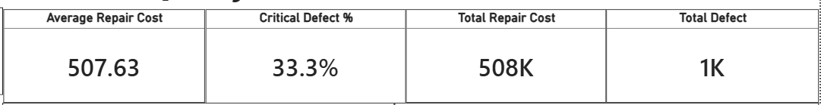
Average Repair Cost – 507.63
This indicates the average cost required to repair a single defect.
➡ Insight: On average, each defect costs approximately 508 units, helping in cost planning and budgeting.

Critical Defect % – 33.3%
This shows that 33.3% of total defects are critical in severity.
➡ Insight:
- One-third of all defects are critical.
- This is relatively high and may indicate serious quality concerns.
Total Repair Cost – 508K
This shows the total financial impact caused by defects.
➡ Insight: The organization has incurred 508K in repair-related expenses.
Total Defect – 1K
This represents the total number of defects recorded in the dataset.
➡ Insight: The volume of defects gives an overall understanding of production quality performance.

Charts
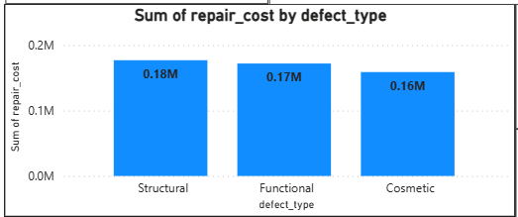
- Repair Cost by Defect Type (Stacked Column Chart)
Defect Types:
- Structural - 0.18M
- Functional - 0.17M
- Cosmetic - 0.16M
➡ Insights:
- Structural defects are the most expensive.
- Functional defects are slightly lower but still significant.
- Cosmetic defects also contribute noticeably to cost.
Conclusion: Structural and Functional defects should be prioritized for quality improvement since they drive higher repair expenses.

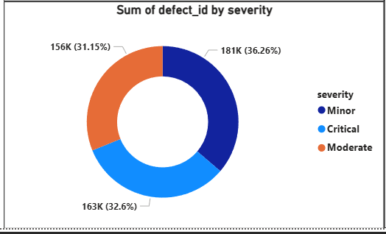
- Severity Distribution (Donut Chart)
Distribution:
- Minor – 36.26%
- Critical – 32.6%
- Moderate – 31.15%
➡ Insights:
- Minor defects slightly dominate.
- Critical defects are almost equal to minor defects.
- The severity distribution is fairly balanced.
Concern: Critical defects forming nearly one-third of total defects is a risk indicator.

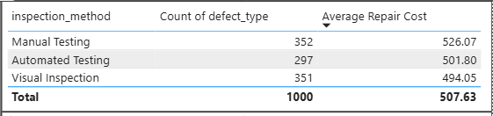
- Inspection Method Performance (Table)
Columns:
- Inspection Method
- Count of defect_type
- Average Repair Cost
Findings:
Inspection Method | Defects | Average Repair Cost
Manual Testing | 352 | 526.07
Visual Inspection | 351 | 494.05
Automated Testing | 297 | 501.80
➡ Insights:
- Manual Testing detects the highest number of defects.
- Manual Testing also has the highest average repair cost.
- Automated Testing detects fewer defects compared to others.
Interpretation: Manual testing may be identifying more complex and costly defects.

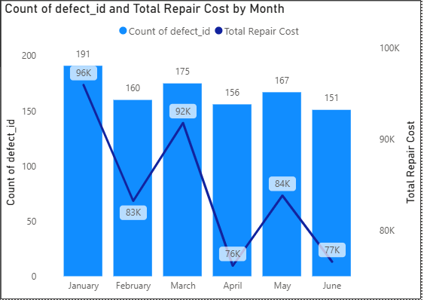
- Monthly Defect & Repair Cost Trend (Line & Stacked Column Chart)
Chart: Count of defect_id and Total Repair Cost by Month
Observations:
- January has the highest defect count (191).
- April shows the lowest repair cost (76K).
- March shows a cost spike (92K) despite moderate defect count.
- Defect volume fluctuates across months.
➡ Insights:
- Higher defect count does not always mean higher repair cost.
- Some months have fewer but more expensive defects.
Conclusion: Severity and defect type impact cost more than quantity alone.
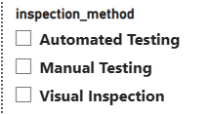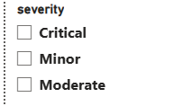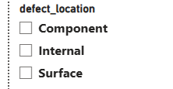
- Slicers (Filter Section)

Inspection Method - Allows analysis of defect trends by:
- Automated Testing
- Manual Testing
- Visual Inspection

Severity - Filters data by:
- Critical
- Minor
- Moderate
Defect Location - Filters by:
- Component
- Internal
- Surface
Purpose: Slicers allow management to analyze specific quality segments and identify root causes.

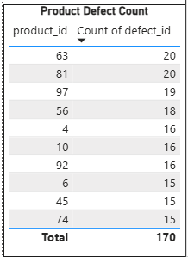
- Product Defect Count (Top 10 Products Table)
Shows top 10 product IDs contributing to highest defects.
Observation: Certain products consistently appear in higher defect counts.
Insight: These products require process review or supplier quality assessment.

Recommendations

1. Reduce Critical Defect Rate: Implement root cause analysis (RCA) for high-severity defects.

2. Focus on Structural Defects: Introduce stricter process control and material quality checks.

3. Improve Automated Testing: Enhance automated inspection to detect high-cost defects earlier.

4. Monitor High-Risk Products: Perform detailed review of products with highest defect counts.

5. Monthly Performance Tracking:

Set KPI target:
- Reduce critical defects below 20%
- Reduce average repair cost by 10%

